LAB # 9
Abstract Data Types
Lab Tasks:-
➢ Considering a bank interface, it will have different concrete classes for receiving bill payments, opening of new accounts and contacting those loan takers whose limits of extension have been expired. Now, develop this scenario on the described ADT and decide which ADT should be used for each concrete class, also implement the whole scenario in multiple java classes.
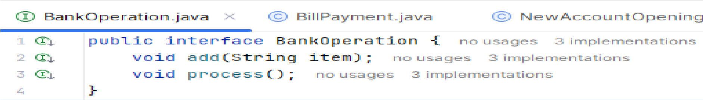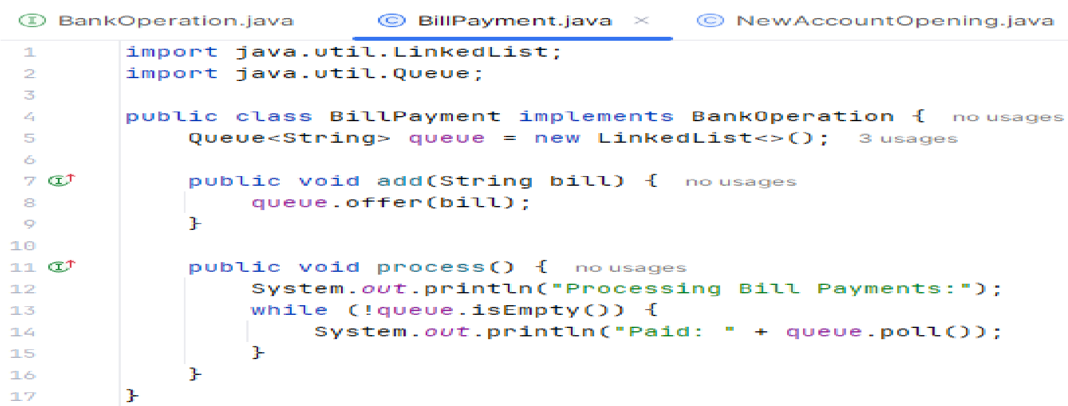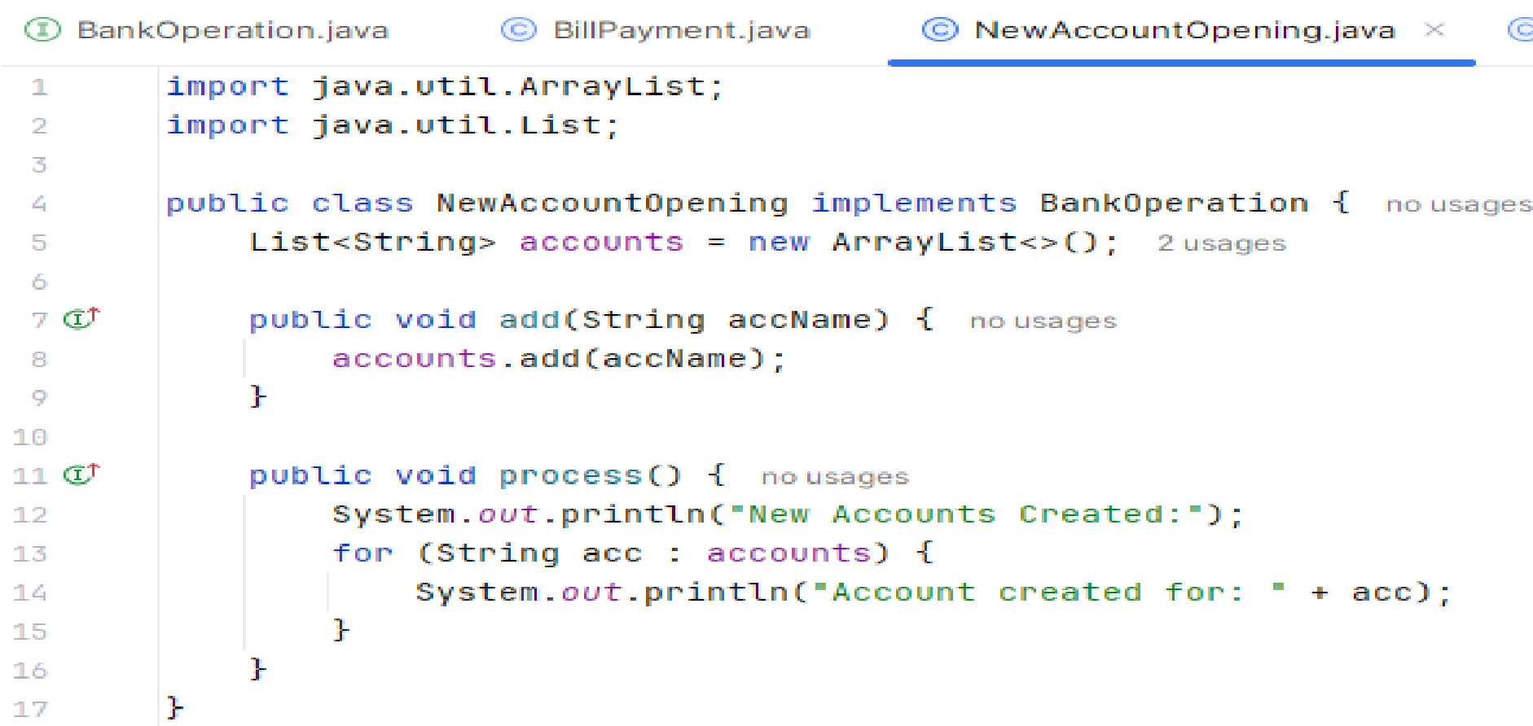
Code:
-

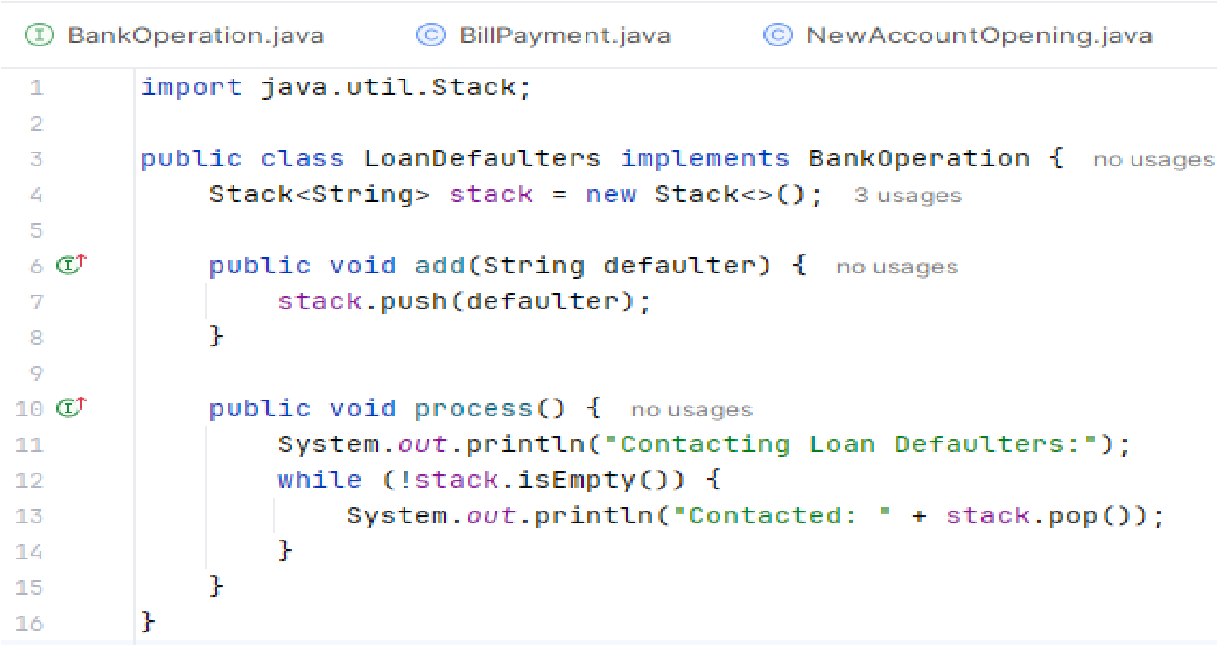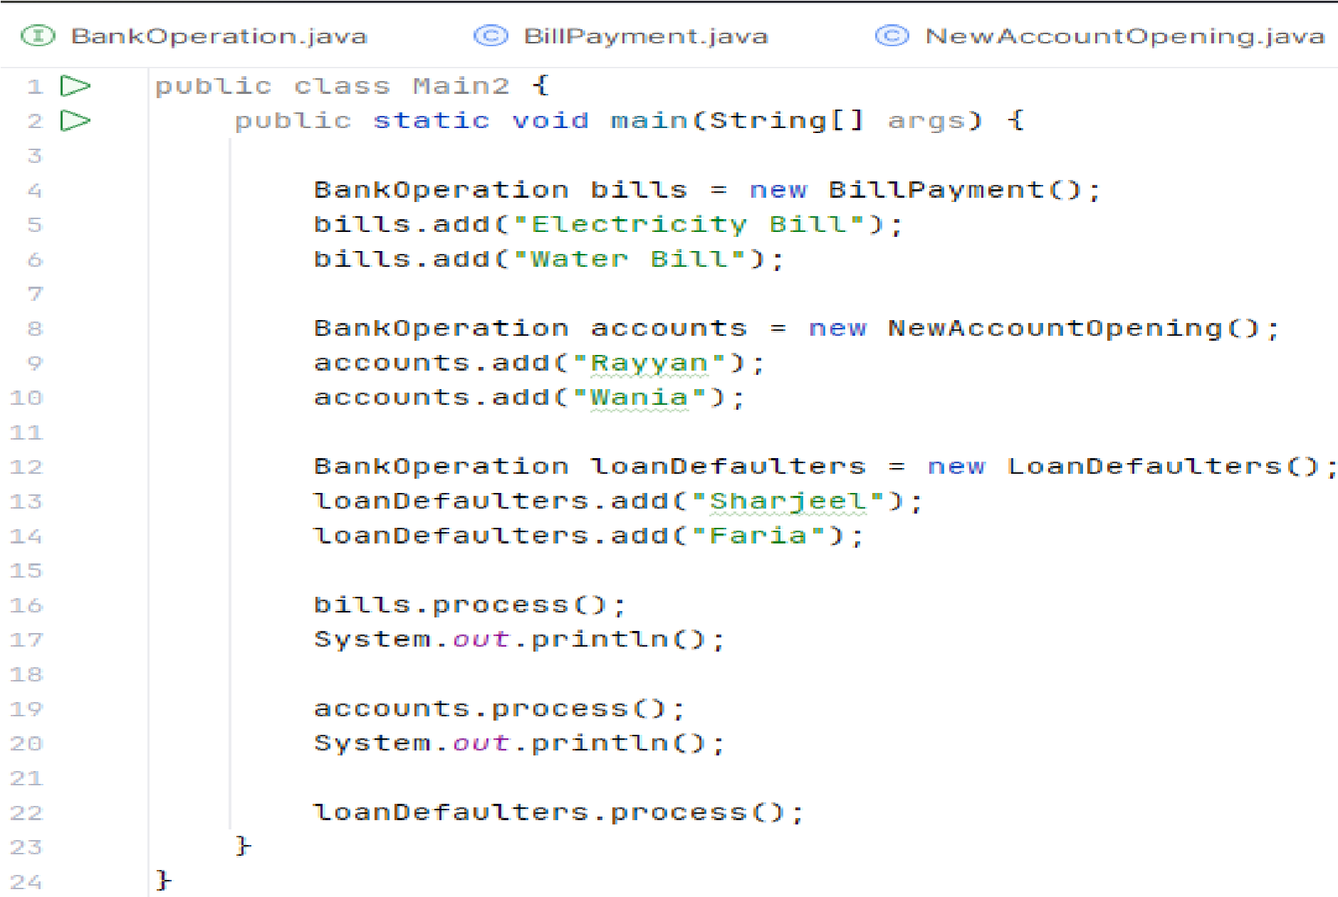

Output:-
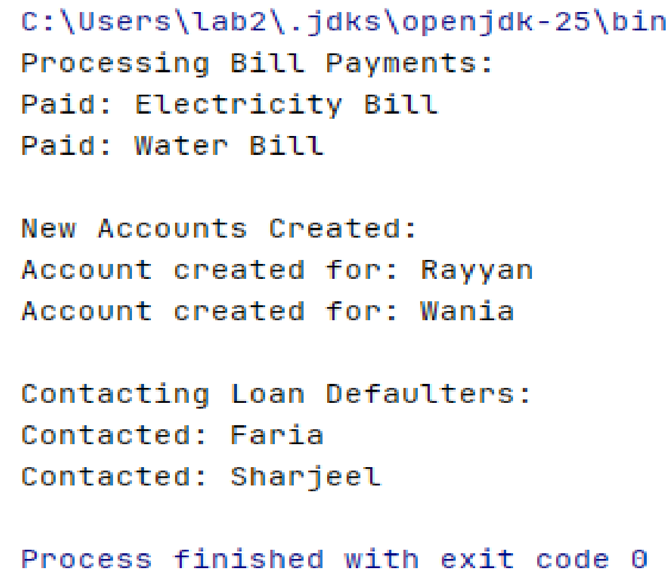

GitHub SS:
-

